Form A2-3: Compliance Verification Report for Inverter Connected Power Generating Modules
This form should be used by the Manufacturer to demonstrate and declare compliance with the requirements of EREC G99. The form can be used in a variety of ways as detailed below:
1. To obtain Fully Type Tested status
The Manufacturer can use this form to obtain Fully Type Tested status for a Power Generating Module by registering this completed form with the Energy Networks Association (ENA) Type Test Verification Report Register.
2. To obtain Type Tested status for a product
This form can be used by the Manufacturer to obtain Type Tested status for a product which is used in a Power Generating Module by registering this form with the relevant parts completed with the Energy Networks Association (ENA) Type Test Verification Report Register.
3. One-off Installation
This form can be used by the Manufacturer or Installer to confirm that the Power Generating Module has been tested to satisfy all or part of the requirements of this EREC G99. This form must be submitted to the DNO as part of the application.
A combination of (2) and (3) can be used as required, together with Form A2-4 where compliance of the Interface Protection is to be demonstrated on site.
Note:
Within this Form A2-3 the term Power Park Module will be used but its meaning can be interpreted within Form A2-3 to mean Power Park Module, Generating Unit or Inverter as appropriate for the context. However, note that compliance must be demonstrated at the Power Park Module level.
If the Power Generating Module is Fully Type Tested and registered with the Energy Networks Association (ENA) Type Test Verification Report Register, the Installation Document (Form A3) should include the Manufacturer’s reference number (the Product ID), and this form does not need to be submitted.
Where the Power Generating Module is not registered with the ENA Type Test Verification Report Register or is not Fully Type Tested this form (all or in parts as applicable) needs to be completed and provided to the DNO, to confirm that the Power Generating Module has been tested to satisfy all or part of the requirements of this EREC G99.
PGM technology |  | MID 33KTL3-X2, MID 36KTL3-X2, MID 40KTL3-X2,MID 50KTL3-X2.
Manufacturer name |  | Shenzhen Growatt New Energy Co., Ltd.
Address |  | 4-13th Floor, Building A, Sino-German Europe Industrial Demonstration Park, No. 1, Hangcheng Avenue, Bao'an District, Shenzhen, Guangdong, China.
Tel | +86 755 2951 5888 | Web site |  | www.ginverter.com
E:mail | Peng.zhu@growatt.com
Registered Capacity |  |  | 50kW

There are four options for Testing: (1) Fully Type Tested, (2) Partially Type Tested, (3) one-off installation, (4) tested on site at time of commissioning. The check box below indicates which tests in this Form have been completed for each of the options. With the exception of Fully Type Tested PGMs tests marked with * may be carried out at the time of commissioning (Form A4).
Tested option: | 1. Fully Type Tested | 2. Partially Type Tested | 3. One-off Man. Info. | 4. Tested on Site at time of Commission-ing
0. Fully Type Tested - all tests detailed below completed and evidence attached to this submission |  | N/A | N/A | N/A
1. Operating Range | N/A
2. PQ – Harmonics
3. PQ – Voltage Fluctuation and Flicker
4. PQ – DC Injection (Power Park Modules only)
5. Power Factor (PF)*
6. Frequency protection trip and ride through tests*
7. Voltage protection trip and ride through tests*
8. Protection – Loss of Mains Test*, Vector Shift and RoCoF Stability Test*
9. LFSM-O Test*
10. Protection – Reconnection Timer*
11. Fault Level Contribution
12. Self-monitoring Solid State Switch
13. Wiring functional tests if required by para 15.2.1 (attach relevant schedule of tests)*
14. Logic Interface (input port)*
* may be carried out at the time of commissioning (Form A.2-4).
Document reference(s) for Manufacturers’ Information:

Manufacturer compliance declaration. - I certify that all products supplied by the company with the above Type Tested Manufacturer’s reference number will be manufactured and tested to ensure that they perform as stated in this document, prior to shipment to site and that no site Modifications are required to ensure that the product meets all the requirements of EREC G99.
Signed |  | On behalf of | Shenzhen Growatt New Energy Co., Ltd.
Note that testing can be done by the Manufacturer of an individual component or by an external test house.
Where parts of the testing are carried out by persons or organisations other than the Manufacturer then that person or organisation shall keep copies of all test records and results supplied to them to verify that the testing has been carried out by people with sufficient technical competency to carry out the tests.

A2-3 Compliance Verification Report –Tests for Type A Inverter Connected Power Generating Modules – test record
1. Operating Range: Two tests should be carried with the Power Generating Module operating at Registered Capacity and connected to a suitable test supply or grid simulation set. The power supplied by the primary source shall be kept stable within ± 5 % of the apparent power value set for the entire duration of each test sequence.
Frequency, voltage and Active Power measurements at the output terminals of the Power Generating Module shall be recorded every second. The tests will verify that the Power Generating Module can operate within the required ranges for the specified period of time.
The Interface Protection shall be disabled during the tests.
In case of a PV Power Park Module the PV primary source may be replaced by a DC source.
In case of a full converter Power Park Module (eg wind) the primary source and the prime mover Inverter/rectifier may be replaced by a DC source.
Test 1  Voltage = 85% of nominal (195.5 V),  Frequency = 47 Hz,  Power Factor = 1,  Period of test 20 s | 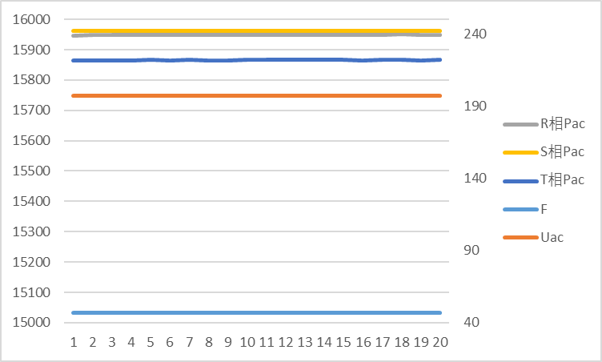
Test 2  Voltage = 85% of nominal (195.5 V),  Frequency = 47.5 Hz,  Power Factor = 1,  Period of test 90 minutes | 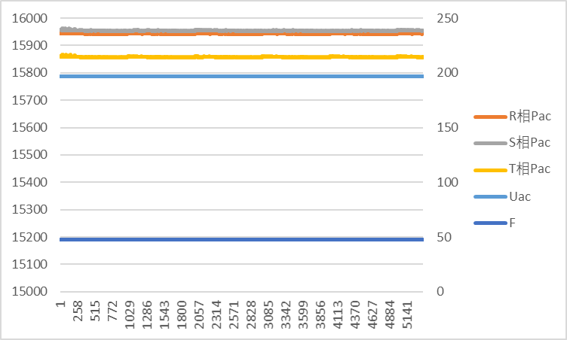
Test 3  Voltage = 110% of nominal (253 V).,  Frequency = 51.5 Hz,  Power Factor = 1,  Period of test 90 minutes | 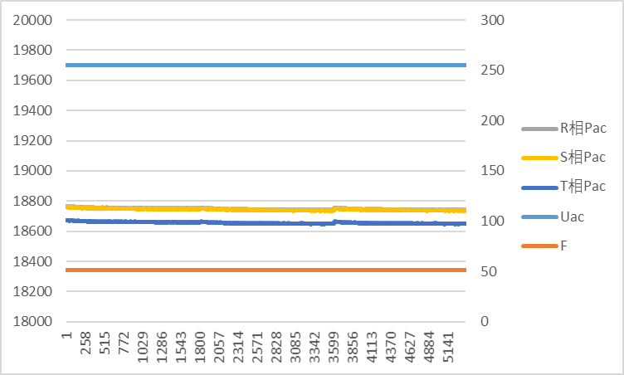
Test 4  Voltage = 110% of nominal (253 V),  Frequency = 52.0 Hz,  Power Factor = 1,  Period of test 15 minutes | 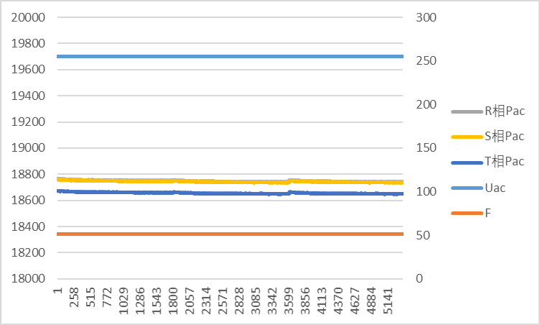
Test 5  Voltage = 100% of nominal (230 V),  Frequency = 50.0 Hz,  Power Factor = 1,  Period of test = 90 minutes | 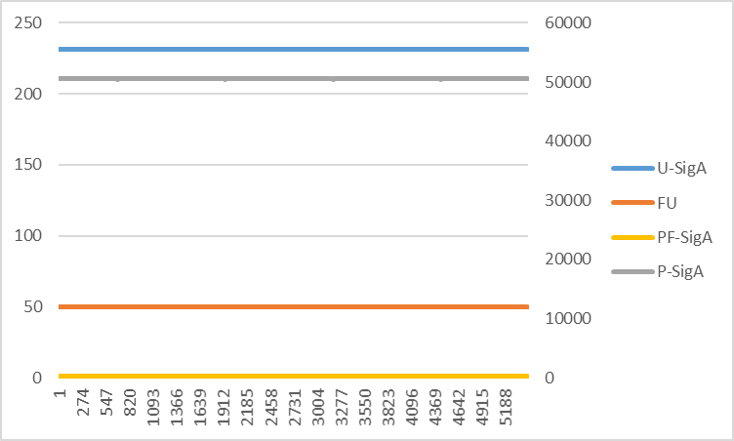
Test 6 RoCoF withstand  Confirm that the Power Generating Module is  capable of staying connected to the Distribution  Network and operate at rates of change of  frequency up to 1 Hzs-1 as measured over a  period of 500 ms. | 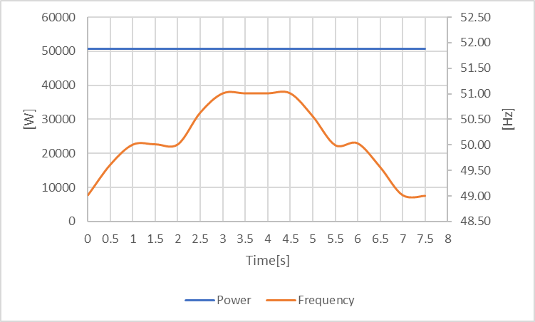
2. Power Quality – Harmonics:
For Power Generating Modules of Registered Capacity of less than 75 A per phase (ie 50 kW) the test requirements are specified in Annex A.7.1.5. These tests should be carried out as specified in BS EN 61000-3-12 The results need to comply with the limits of Table 2 of BS EN 61000-3-12 for single phase equipment and Table 3 of BS EN 610000-3-12 for three phase equipment.
Power Generating Modules with emissions close to the limits laid down in BS EN 61000-3-12 may require the installation of a transformer between 2 and 4 times the rating of the Power Generating Module in order to accept the connection to a Distribution Network.
For Power Generating Modules of Registered Capacity of greater than 75 A per phase (ie 50 kW) the installation must be designed in accordance with EREC G5.
Power Generating Module tested to BS EN 61000-3-12

Power Generating Module rating per phase (rpp) |  |  |  | 11.00 | kVA | Harmonic % = Measured Value (A) x 23/rating per phase (kVA)
Average harmonic current results – Phase 1
Harmonic |  | At 45-55% of Registered Capacity |  | 100% of Registered Capacity |  | Limit in BS EN 61000-3-12
 |  | Measured Value MV in Amps | % | Measured Value MV in Amps | % | 1 phase | 3 phase
2 |  | 0.0259 | 0.0541 | 0.0257 | 0.0538 | 8% | 8%
3 |  | 0.0399 | 0.0833 | 0.0400 | 0.0837 | 21.6% | Not stated
4 |  | 0.0261 | 0.0546 | 0.0255 | 0.0533 | 4% | 4%
5 |  | 0.0370 | 0.0775 | 0.0359 | 0.0751 | 10.7% | 10.7%
6 |  | 0.0216 | 0.0452 | 0.0217 | 0.0454 | 2.67% | 2.67%
7 |  | 0.0682 | 0.1425 | 0.0683 | 0.1428 | 7.2% | 7.2%
8 |  | 0.0226 | 0.0473 | 0.0223 | 0.0467 | 2% | 2%
9 |  | 0.0246 | 0.0514 | 0.0248 | 0.0518 | 3.8% | Not stated
10 |  | 0.0218 | 0.0455 | 0.0218 | 0.0456 | 1.6% | 1.6%
11 |  | 0.0777 | 0.1625 | 0.0785 | 0.1640 | 3.1% | 3.1%
12 |  | 0.0218 | 0.0455 | 0.0219 | 0.0457 | 1.33% | 1.33%
13 |  | 0.0448 | 0.0937 | 0.0452 | 0.0945 | 2% | 2%
THD |  |  | 0.2253 | - | 0.2266 | 23% | 13%
PWHD |  |  | 0.9116 | - | 0.9187 | 23% | 22%

Average harmonic current results – Phase 2
Harmonic |  | At 45-55% of Registered Capacity |  | 100% of Registered Capacity |  | Limit in BS EN 61000-3-12
 |  | Measured Value MV in Amps | % | Measured Value MV in Amps | % | 1 phase | 3 phase
2 |  | 0.0259 | 0.0541 | 0.0258 | 0.0539 | 8% | 8%
3 |  | 0.0398 | 0.0833 | 0.0399 | 0.0834 | 21.6% | Not stated
4 |  | 0.0261 | 0.0546 | 0.0258 | 0.0539 | 4% | 4%
5 |  | 0.0371 | 0.0775 | 0.0360 | 0.0752 | 10.7% | 10.7%
6 |  | 0.0216 | 0.0453 | 0.0218 | 0.0456 | 2.67% | 2.67%
7 |  | 0.0682 | 0.1425 | 0.0684 | 0.1430 | 7.2% | 7.2%
8 |  | 0.0226 | 0.0473 | 0.0224 | 0.0468 | 2% | 2%
9 |  | 0.0246 | 0.0515 | 0.0247 | 0.0516 | 3.8% | Not stated
10 |  | 0.0218 | 0.0455 | 0.0219 | 0.0457 | 1.6% | 1.6%
11 |  | 0.0777 | 0.1625 | 0.0784 | 0.1640 | 3.1% | 3.1%
12 |  | 0.0218 | 0.0455 | 0.0220 | 0.0460 | 1.33% | 1.33%
13 |  | 0.0448 | 0.0936 | 0.0452 | 0.0944 | 2% | 2%
THD | - |  | 0.2253 | - | 0.2267 | 23% | 13%
PWHD | - |  | 0.9116 | - | 0.9194 | 23% | 22%

Average harmonic current results – Phase 3
Harmonic | At 45-55% of Registered Capacity |  | 100% of Registered Capacity |  | Limit in BS EN 61000-3-12
 | Measured Value MV in Amps | % | Measured Value MV in Amps | % | 1 phase | 3 phase
2 | 0.0258 | 0.0540 | 0.0258 | 0.0540 | 8% | 8%
3 | 0.0398 | 0.0833 | 0.0400 | 0.0835 | 21.6% | Not stated
4 | 0.0261 | 0.0546 | 0.0256 | 0.0535 | 4% | 4%
5 | 0.0371 | 0.0775 | 0.0360 | 0.0752 | 10.7% | 10.7%
6 | 0.0216 | 0.0452 | 0.0218 | 0.0457 | 2.67% | 2.67%
7 | 0.0682 | 0.1425 | 0.0683 | 0.1429 | 7.2% | 7.2%
8 | 0.0226 | 0.0473 | 0.0223 | 0.0467 | 2% | 2%
9 | 0.0246 | 0.0515 | 0.0247 | 0.0517 | 3.8% | Not stated
10 | 0.0218 | 0.0455 | 0.0219 | 0.0457 | 1.6% | 1.6%
11 | 0.0777 | 0.1625 | 0.0785 | 0.1641 | 3.1% | 3.1%
12 | 0.0218 | 0.0456 | 0.0219 | 0.0458 | 1.33% | 1.33%
13 | 0.0448 | 0.0937 | 0.0451 | 0.0942 | 2% | 2%
THD | - | 0.2253 | - | 0.2267 | 23% | 13%
PWHD | - | 0.9116 | - | 0.9194 | 23% | 22%

Power Generating Module rating per phase (rpp) |  |  |  | 12.00 | kVA | Harmonic % = Measured Value (A) x 23/rating per phase (kVA)
Average harmonic current results – Phase 1
Harmonic |  | At 45-55% of Registered Capacity |  | 100% of Registered Capacity |  | Limit in BS EN 61000-3-12
 |  | Measured Value MV in Amps | % | Measured Value MV in Amps | % | 1 phase | 3 phase
2 |  | 0.0253 | 0.0485 | 0.0261 | 0.0501 | 8% | 8%
3 |  | 0.0399 | 0.0766 | 0.0401 | 0.0768 | 21.6% | Not stated
4 |  | 0.0255 | 0.0490 | 0.0256 | 0.0490 | 4% | 4%
5 |  | 0.0351 | 0.0673 | 0.0356 | 0.0683 | 10.7% | 10.7%
6 |  | 0.0219 | 0.0419 | 0.0218 | 0.0417 | 2.67% | 2.67%
7 |  | 0.0675 | 0.1293 | 0.0676 | 0.1296 | 7.2% | 7.2%
8 |  | 0.0223 | 0.0428 | 0.0224 | 0.0429 | 2% | 2%
9 |  | 0.0247 | 0.0473 | 0.0248 | 0.0475 | 3.8% | Not stated
10 |  | 0.0218 | 0.0419 | 0.0219 | 0.0420 | 1.6% | 1.6%
11 |  | 0.0777 | 0.1490 | 0.0780 | 0.1495 | 3.1% | 3.1%
12 |  | 0.0220 | 0.0422 | 0.0221 | 0.0423 | 1.33% | 1.33%
13 |  | 0.0450 | 0.0863 | 0.0454 | 0.0871 | 2% | 2%
THD |  |  | 0.2256 | - | 0.2268 | 23% | 13%
PWHD |  |  | 0.9171 | - | 0.9219 | 23% | 22%

Average harmonic current results – Phase 2
Harmonic |  | At 45-55% of Registered Capacity |  | 100% of Registered Capacity |  | Limit in BS EN 61000-3-12
 |  | Measured Value MV in Amps | % | Measured Value MV in Amps | % | 1 phase | 3 phase
2 |  | 0.0253 | 0.0485 | 0.0261 | 0.0501 | 8% | 8%
3 |  | 0.0399 | 0.0765 | 0.0400 | 0.0767 | 21.6% | Not stated
4 |  | 0.0256 | 0.0491 | 0.0256 | 0.0491 | 4% | 4%
5 |  | 0.0351 | 0.0673 | 0.0357 | 0.0684 | 10.7% | 10.7%
6 |  | 0.0218 | 0.0417 | 0.0220 | 0.0422 | 2.67% | 2.67%
7 |  | 0.0675 | 0.1294 | 0.0675 | 0.1293 | 7.2% | 7.2%
8 |  | 0.0224 | 0.0429 | 0.0225 | 0.0432 | 2% | 2%
9 |  | 0.0247 | 0.0473 | 0.0248 | 0.0475 | 3.8% | Not stated
10 |  | 0.0218 | 0.0418 | 0.0219 | 0.0421 | 1.6% | 1.6%
11 |  | 0.0779 | 0.1493 | 0.0778 | 0.1491 | 3.1% | 3.1%
12 |  | 0.0220 | 0.0422 | 0.0220 | 0.0422 | 1.33% | 1.33%
13 |  | 0.0452 | 0.0867 | 0.0455 | 0.0872 | 2% | 2%
THD | - |  | 0.2258 | - | 0.2267 | 23% | 13%
PWHD | - |  | 0.9176 | - | 0.9215 | 23% | 22%

Average harmonic current results – Phase 3
Harmonic | At 45-55% of Registered Capacity |  | 100% of Registered Capacity |  | Limit in BS EN 61000-3-12
 | Measured Value MV in Amps | % | Measured Value MV in Amps | % | 1 phase | 3 phase
2 | 0.0253 | 0.0484 | 0.0261 | 0.0500 | 8% | 8%
3 | 0.0399 | 0.0764 | 0.0401 | 0.0768 | 21.6% | Not stated
4 | 0.0256 | 0.0490 | 0.0258 | 0.0494 | 4% | 4%
5 | 0.0350 | 0.0671 | 0.0358 | 0.0686 | 10.7% | 10.7%
6 | 0.0218 | 0.0417 | 0.0220 | 0.0422 | 2.67% | 2.67%
7 | 0.0676 | 0.1295 | 0.0676 | 0.1295 | 7.2% | 7.2%
8 | 0.0223 | 0.0427 | 0.0227 | 0.0434 | 2% | 2%
9 | 0.0247 | 0.0473 | 0.0247 | 0.0473 | 3.8% | Not stated
10 | 0.0218 | 0.0418 | 0.0218 | 0.0419 | 1.6% | 1.6%
11 | 0.0779 | 0.1493 | 0.0781 | 0.1497 | 3.1% | 3.1%
12 | 0.0219 | 0.0421 | 0.0220 | 0.0421 | 1.33% | 1.33%
13 | 0.0451 | 0.0864 | 0.0453 | 0.0869 | 2% | 2%
THD | - | 0.2256 | - | 0.2267 | 23% | 13%
PWHD | - | 0.9170 | - | 0.9205 | 23% | 22%
Power Generating Module rating per phase (rpp) |  |  | 13.33 | kVA | Harmonic % = Measured Value (A) x 23/rating per phase (kVA)
Average harmonic current results – Phase 1
Harmonic | At 45-55% of Registered Capacity |  | 100% of Registered Capacity |  | Limit in BS EN 61000-3-12
 | Measured Value MV in Amps | % | Measured Value MV in Amps | % | 1 phase | 3 phase
2 | 0.0255 | 0.0439 | 0.0260 | 0.0448 | 8% | 8%
3 | 0.0400 | 0.0691 | 0.0401 | 0.0691 | 21.6% | Not stated
4 | 0.0256 | 0.0442 | 0.0256 | 0.0441 | 4% | 4%
5 | 0.0347 | 0.0599 | 0.0356 | 0.0615 | 10.7% | 10.7%
6 | 0.0216 | 0.0373 | 0.0217 | 0.0374 | 2.67% | 2.67%
7 | 0.0678 | 0.1170 | 0.0678 | 0.1170 | 7.2% | 7.2%
8 | 0.0225 | 0.0388 | 0.0223 | 0.0385 | 2% | 2%
9 | 0.0248 | 0.0428 | 0.0247 | 0.0426 | 3.8% | Not stated
10 | 0.0220 | 0.0379 | 0.0220 | 0.0380 | 1.6% | 1.6%
11 | 0.0778 | 0.1342 | 0.0779 | 0.1344 | 3.1% | 3.1%
12 | 0.0221 | 0.0381 | 0.0220 | 0.0380 | 1.33% | 1.33%
13 | 0.0451 | 0.0779 | 0.0453 | 0.0782 | 2% | 2%
THD | - | 0.2259 | - | 0.2266 | 23% | 13%
PWHD | - | 0.9178 | - | 0.9109 | 23% | 22%

Average harmonic current results – Phase 2
Harmonic |  | At 45-55% of Registered Capacity |  | 100% of Registered Capacity |  | Limit in BS EN 61000-3-12
 |  | Measured Value MV in Amps | % | Measured Value MV in Amps | % | 1 phase | 3 phase
2 |  | 0.0256 | 0.0441 | 0.0259 | 0.0447 | 8% | 8%
3 |  | 0.0400 | 0.0690 | 0.0401 | 0.0692 | 21.6% | Not stated
4 |  | 0.0254 | 0.0439 | 0.0256 | 0.0441 | 4% | 4%
5 |  | 0.0348 | 0.0601 | 0.0356 | 0.0614 | 10.7% | 10.7%
6 |  | 0.0219 | 0.0378 | 0.0217 | 0.0374 | 2.67% | 2.67%
7 |  | 0.0677 | 0.1167 | 0.0678 | 0.1169 | 7.2% | 7.2%
8 |  | 0.0223 | 0.0385 | 0.0224 | 0.0386 | 2% | 2%
9 |  | 0.0247 | 0.0427 | 0.0248 | 0.0427 | 3.8% | Not stated
10 |  | 0.0219 | 0.0378 | 0.0220 | 0.0380 | 1.6% | 1.6%
11 |  | 0.0777 | 0.1340 | 0.0780 | 0.1346 | 3.1% | 3.1%
12 |  | 0.0220 | 0.0379 | 0.0221 | 0.0381 | 1.33% | 1.33%
13 |  | 0.0450 | 0.0776 | 0.0452 | 0.0780 | 2% | 2%
THD | - |  | 0.2258 | - | 0.2267 | 23% | 13%
PWHD | - |  | 0.9184 | - | 0.9219 | 23% | 22%

Average harmonic current results – Phase 3
Harmonic |  | At 45-55% of Registered Capacity |  | 100% of Registered Capacity |  | Limit in BS EN 61000-3-12
 |  | Measured Value MV in Amps | % | Measured Value MV in Amps | % | 1 phase | 3 phase
2 |  | 0.0257 | 0.0443 | 0.0259 | 0.0447 | 8% | 8%
3 |  | 0.0401 | 0.0692 | 0.0400 | 0.0690 | 21.6% | Not stated
4 |  | 0.0256 | 0.0441 | 0.0257 | 0.0443 | 4% | 4%
5 |  | 0.0348 | 0.0600 | 0.0356 | 0.0615 | 10.7% | 10.7%
6 |  | 0.0217 | 0.0374 | 0.0219 | 0.0377 | 2.67% | 2.67%
7 |  | 0.0677 | 0.1168 | 0.0679 | 0.1171 | 7.2% | 7.2%
8 |  | 0.0224 | 0.0387 | 0.0226 | 0.0390 | 2% | 2%
9 |  | 0.0247 | 0.0427 | 0.0247 | 0.0426 | 3.8% | Not stated
10 |  | 0.0218 | 0.0376 | 0.0219 | 0.0378 | 1.6% | 1.6%
11 |  | 0.0778 | 0.1342 | 0.0780 | 0.1346 | 3.1% | 3.1%
12 |  | 0.0220 | 0.0380 | 0.0219 | 0.0378 | 1.33% | 1.33%
13 |  | 0.0452 | 0.0779 | 0.0452 | 0.0780 | 2% | 2%
THD | - |  | 0.2259 | - | 0.2269 | 23% | 13%
PWHD | - |  | 0.9185 | - | 0.9224 | 23% | 22%
Power Generating Module rating per phase (rpp) |  |  |  | 16.67 | kVA | Harmonic % = Measured Value (A) x 23/rating per phase (kVA)
Average harmonic current results – Phase 1
Harmonic |  | At 45-55% of Registered Capacity |  | 100% of Registered Capacity |  | Limit in BS EN 61000-3-12
 |  | Measured Value MV in Amps | % | Measured Value MV in Amps | % | 1 phase | 3 phase
2 |  | 0.0253 | 0.0349 | 0.0256 | 0.0354 | 8% | 8%
3 |  | 0.0403 | 0.0556 | 0.0405 | 0.0559 | 21.6% | Not stated
4 |  | 0.0252 | 0.0348 | 0.0251 | 0.0346 | 4% | 4%
5 |  | 0.0363 | 0.0501 | 0.0375 | 0.0517 | 10.7% | 10.7%
6 |  | 0.0217 | 0.0300 | 0.0216 | 0.0298 | 2.67% | 2.67%
7 |  | 0.0675 | 0.0932 | 0.0688 | 0.0949 | 7.2% | 7.2%
8 |  | 0.0222 | 0.0306 | 0.0223 | 0.0307 | 2% | 2%
9 |  | 0.0246 | 0.0340 | 0.0248 | 0.0342 | 3.8% | Not stated
10 |  | 0.0219 | 0.0302 | 0.0218 | 0.0301 | 1.6% | 1.6%
11 |  | 0.0775 | 0.1070 | 0.0777 | 0.1072 | 3.1% | 3.1%
12 |  | 0.0218 | 0.0301 | 0.0218 | 0.0301 | 1.33% | 1.33%
13 |  | 0.0450 | 0.0621 | 0.0451 | 0.0622 | 2% | 2%
THD |  |  | 0.2251 | - | 0.2259 | 23% | 13%
PWHD |  |  | 0.9133 | - | 0.9136 | 23% | 22%

Average harmonic current results – Phase 2
Harmonic |  | At 45-55% of Registered Capacity |  | 100% of Registered Capacity |  | Limit in BS EN 61000-3-12
 |  | Measured Value MV in Amps | % | Measured Value MV in Amps | % | 1 phase | 3 phase
2 |  | 0.0253 | 0.0349 | 0.0256 | 0.0354 | 8% | 8%
3 |  | 0.0403 | 0.0556 | 0.0405 | 0.0559 | 21.6% | Not stated
4 |  | 0.0253 | 0.0348 | 0.0251 | 0.0346 | 4% | 4%
5 |  | 0.0363 | 0.0501 | 0.0375 | 0.0518 | 10.7% | 10.7%
6 |  | 0.0218 | 0.0300 | 0.0218 | 0.0301 | 2.67% | 2.67%
7 |  | 0.0676 | 0.0933 | 0.0687 | 0.0948 | 7.2% | 7.2%
8 |  | 0.0222 | 0.0307 | 0.0223 | 0.0307 | 2% | 2%
9 |  | 0.0249 | 0.0343 | 0.0247 | 0.0341 | 3.8% | Not stated
10 |  | 0.0218 | 0.0301 | 0.0219 | 0.0302 | 1.6% | 1.6%
11 |  | 0.0775 | 0.1070 | 0.0777 | 0.1072 | 3.1% | 3.1%
12 |  | 0.0219 | 0.0302 | 0.0219 | 0.0301 | 1.33% | 1.33%
13 |  | 0.0450 | 0.0620 | 0.0450 | 0.0621 | 2% | 2%
THD | - |  | 0.2252 | - | 0.2259 | 23% | 13%
PWHD | - |  | 0.9134 | - | 0.9135 | 23% | 22%

Average harmonic current results – Phase 3
Harmonic |  | At 45-55% of Registered Capacity |  | 100% of Registered Capacity |  | Limit in BS EN 61000-3-12
 |  | Measured Value MV in Amps | % | Measured Value MV in Amps | % | 1 phase | 3 phase
2 |  | 0.0254 | 0.0350 | 0.0256 | 0.0353 | 8% | 8%
3 |  | 0.0403 | 0.0556 | 0.0405 | 0.0559 | 21.6% | Not stated
4 |  | 0.0253 | 0.0348 | 0.0250 | 0.0344 | 4% | 4%
5 |  | 0.0363 | 0.0501 | 0.0375 | 0.0517 | 10.7% | 10.7%
6 |  | 0.0218 | 0.0300 | 0.0217 | 0.0299 | 2.67% | 2.67%
7 |  | 0.0674 | 0.0931 | 0.0688 | 0.0949 | 7.2% | 7.2%
8 |  | 0.0223 | 0.0307 | 0.0222 | 0.0307 | 2% | 2%
9 |  | 0.0248 | 0.0343 | 0.0248 | 0.0342 | 3.8% | Not stated
10 |  | 0.0219 | 0.0303 | 0.0218 | 0.0300 | 1.6% | 1.6%
11 |  | 0.0775 | 0.1069 | 0.0777 | 0.1072 | 3.1% | 3.1%
12 |  | 0.0218 | 0.0301 | 0.0219 | 0.0301 | 1.33% | 1.33%
13 |  | 0.0450 | 0.0621 | 0.0451 | 0.0622 | 2% | 2%
THD | - |  | 0.2252 | - | 0.2259 | 23% | 13%
PWHD | - |  | 0.9133 | - | 0.9137 | 23% | 22%

3. Power Quality – Voltage fluctuations and Flicker:
For Power Generating Modules of Registered Capacity of less than 75 A per phase (ie 50 kW) these tests should be undertaken in accordance with Annex A.7.1.4.3. Results should be normalised to a standard source impedance, or if this results in figures above the limits set in BS EN 61000-3-11 to a suitable Maximum Impedance.
For Power Generating Modules of Registered Capacity of greater than 75 A per phase (ie 50 kW) the installation must be designed in accordance with EREC P28.
 |  |  | Starting |  |  |  |  |  |  |  |  | Stopping |  |  |  |  |  |  |  | Running
 |  |  | d max |  |  | d c |  |  | d(t) |  |  | d max |  |  |  | d c |  |  | d(t) |  |  | P st |  |  |  |  | P lt 2 hours
Measured Values at test impedance |  |  | 1.05 |  |  | 0.75 |  |  | 0 |  |  | 1.07 |  |  |  | 0.70 |  |  | 0 |  |  | 0.54 |  |  |  |  | 0.54
Normalised to standard impedance |  |  | 1.05 |  |  | 0.75 |  |  | 0 |  |  | 1.07 |  |  |  | 0.70 |  |  | 0 |  |  | 0.54 |  |  |  |  | 0.54
Normalised to required maximum impedance |  |  | - |  |  | - |  |  | - |  |  | - |  |  |  | - |  |  | - |  |  | - |  |  |  |  | -
Limits set under BS EN 61000-3-11 |  |  | 4% |  |  | 3.3% |  |  | 3.3% |  |  | 4% |  |  |  | 3.3% |  |  | 3.3% |  |  | 1.0 |  |  |  |  | 0.65
Test Impedance |  | R |  |  | 0.24 |  |  |  |  | Ω |  |  |  | Xl |  |  |  | 0.15 |  |  |  |  |  |  |  |  |  | Ω
Standard Impedance |  | R |  |  | 0.24 *  0.4 ^ |  |  |  |  | Ω |  |  |  | Xl |  |  |  | 0.15 *  0.25 ^ |  |  |  |  |  |  |  |  |  | Ω
Maximum Impedance |  | R |  |  | - |  |  |  |  | Ω |  |  |  | Xl |  |  |  | - |  |  |  |  |  |  |  |  |  | Ω
* Applies to three phase and split single phase Power Generating Modules.
^ Applies to single phase Power Generating Module and Power Generating Modules using two phases on a three phase system
For voltage change and flicker measurements the following formula is to be used to convert the measured values to the normalised values where the Power Factor of the generation output is 0.98 or above.
Normalised value = Measured value x reference source resistance/measured source resistance at test point
Single phase units reference source resistance is 0.4 Ω
Two phase units in a three phase system reference source resistance is 0.4 Ω
Two phase units in a split phase system reference source resistance is 0.24 Ω
Three phase units reference source resistance is 0.24 Ω
Where the Power Factor of the output is under 0.98 then the Xl to R ratio of the test impedance should be close to that of the Standard Impedance.
The stopping test should be a trip from full load operation.
The duration of these tests need to comply with the particular requirements set out in the testing notes for the technology under test. Dates and location of the test need to be noted below
Test start date |  |  |  |  | 10,Jan, 2023 |  |  |  |  |  |  |  | Test end date |  |  |  |  |  |  |  |  |  | 10,Jan, 2023
Test location |  |  |  |  | Growatt certified testing laboratory
4. Power quality – DC injection: The tests should be carried out on a single Generating Unit. Tests are to be carried out at three defined power levels ±5%. At 230 V a 50 kW three phase Inverter has a current output of 72.4 A so DC limit is 181.0mA. These tests should be undertaken in accordance with Annex A.7.1.4.4.
Test power level（33K） |  |  |  |  |  |  | 10% |  |  |  |  |  | 55% |  |  |  |  |  |  |  |  |  | 100%
Recorded value in Amps |  |  |  |  |  |  | 153mA |  |  |  |  |  | 166mA |  |  |  |  |  |  |  |  |  | 172mA
as % of rated AC current |  |  |  |  |  |  | 0.11% |  |  |  |  |  | 0.12% |  |  |  |  |  |  |  |  |  | 0.12%
Limit |  |  |  |  |  |  | 0.25% |  |  |  |  |  | 0.25% |  |  |  |  |  |  |  |  |  | 0.25%
Test power level（36K） |  |  |  |  |  |  | 10% |  |  |  |  |  | 55% |  |  |  |  |  |  |  |  |  | 100%
Recorded value in Amps |  |  |  |  |  |  | 235mA |  |  |  |  |  | 251mA |  |  |  |  |  |  |  |  |  | 256mA
as % of rated AC current |  |  |  |  |  |  | 0.15% |  |  |  |  |  | 0.16% |  |  |  |  |  |  |  |  |  | 0.16%
Limit |  |  |  |  |  |  | 0.25% |  |  |  |  |  | 0.25% |  |  |  |  |  |  |  |  |  | 0.25%
Test power level（40K） |  |  |  |  |  |  | 10% |  |  |  |  |  | 55% |  |  |  |  |  |  |  |  |  | 100%
Recorded value in Amps |  |  |  |  |  |  | 280mA |  |  |  |  |  | 299mA |  |  |  |  |  |  |  |  |  | 317mA
as % of rated AC current |  |  |  |  |  |  | 0.16% |  |  |  |  |  | 0.17% |  |  |  |  |  |  |  |  |  | 0.18%
Limit |  |  |  |  |  |  | 0.25% |  |  |  |  |  | 0.25% |  |  |  |  |  |  |  |  |  | 0.25%
Test power level（50K） |  |  |  |  |  |  | 10% |  |  |  |  |  | 55% |  |  |  |  |  |  |  |  |  | 100%
Recorded value in Amps |  |  |  |  |  |  | 365mA |  |  |  |  |  | 380mA |  |  |  |  |  |  |  |  |  | 391mA
as % of rated AC current |  |  |  |  |  |  | 0.17% |  |  |  |  |  | 0.17% |  |  |  |  |  |  |  |  |  | 0.18%
Limit |  |  |  |  |  |  | 0.25% |  |  |  |  |  | 0.25% |  |  |  |  |  |  |  |  |  | 0.25%
5. Power Factor: The tests should be carried out on a single Power Generating Module. Tests are to be carried out at three voltage levels and at Registered Capacity. Voltage to be maintained within ±1.5% of the stated level during the test. These tests should be undertaken in accordance with Annex A.7.1.4.2.
Voltage |  |  |  |  |  |  |  | 0.94 pu (216.2 V) |  |  |  |  |  |  | 1 pu (230 V) |  |  |  |  |  |  |  |  | 1.1 pu (253V)
Measured value |  |  |  |  |  |  |  | 0.9981/0.9985/0.9987 |  |  |  |  |  |  | 0.9998/0.9999/0.9997 |  |  |  |  |  |  |  |  | 0.9985/0.9986/0.9983
Power Factor Limit |  |  |  |  |  |  |  | >0.95 |  |  |  |  |  |  | >0.95 |  |  |  |  |  |  |  |  | >0.95
6. Protection – Frequency tests: These tests should be carried out in accordance with the Annex A.7.1.2.3.
Function | Setting |  |  |  |  |  |  |  |  | Trip test |  |  |  |  |  |  |  | “No trip tests”
 | Frequency |  |  |  |  | Time delay |  |  |  | Frequency |  |  |  | Time  delay |  |  |  | Frequency /time |  |  |  |  |  |  |  | Confirm no trip
U/F stage 1 | 47.5 Hz |  |  |  |  | 20 s |  |  |  | 47.49Hz |  |  |  | 20.015s |  |  |  | 47.7 Hz  30 s |  |  |  |  |  |  |  | No trip
U/F stage 2 | 47 Hz |  |  |  |  | 0.5 s |  |  |  | 47.00Hz |  |  |  | 0.511s |  |  |  | 47.2 Hz  19.5 s |  |  |  |  |  |  |  | No trip
 |  |  |  |  |  |  |  |  |  |  |  |  |  |  |  |  |  | 46.8 Hz  0.45 s |  |  |  |  |  |  |  | No trip
O/F | 52 Hz |  |  |  |  | 0.5 s |  |  |  | 52.00Hz |  |  |  | 0.512s |  |  |  | 51.8 Hz  120 s |  |  |  |  |  |  |  | No trip
 |  |  |  |  |  |  |  |  |  |  |  |  |  |  |  |  |  | 52.2 Hz  0.45 s |  |  |  |  |  |  |  | No trip
Note. For frequency trip tests the frequency required to trip is the setting ± 0.1 Hz. In order to measure the time delay a larger deviation than the minimum required to operate the projection can be used. The “No trip tests” need to be carried out at the setting ± 0.2 Hz and for the relevant times as shown in the table above to ensure that the protection will not trip in error.
7. Protection – Voltage tests: These tests should be carried out in accordance with Annex A.7.1.2.2.
Function |  | Setting |  |  |  |  |  |  |  | Trip test |  |  |  |  |  |  |  | “No trip tests”
 |  | Voltage |  |  |  | Time delay |  |  |  | Voltage |  |  |  | Time delay |  |  |  | Voltage /time |  |  |  |  |  |  |  | Confirm no trip
U/V |  | 0.8 pu (184 V) |  |  |  | 2.5 s |  |  |  | 184.69 |  |  |  | 2.509s |  |  |  | 188 V  5.0 s |  |  |  |  |  |  |  | No trip
 |  |  |  |  |  |  |  |  |  |  |  |  |  |  |  |  |  | 180 V  2.45 s |  |  |  |  |  |  |  | No trip
O/V stage 1 |  | 1.14 pu (262.2V) |  |  |  | 1.0 s |  |  |  | 262.54V |  |  |  | 1.015s |  |  |  | 258.2 V  5.0 s |  |  |  |  |  |  |  | No trip
O/V stage 2 |  | 1.19 pu (273.7V) |  |  |  | 0.5 s |  |  |  | 274.05V |  |  |  | 0.517s |  |  |  | 269.7 V  0.95s |  |  |  |  |  |  |  | No trip
 |  |  |  |  |  |  |  |  |  |  |  |  |  |  |  |  |  | 277.7 V  0.45 s |  |  |  |  |  |  |  | No trip
Note for Voltage tests the Voltage required to trip is the setting ±3.45 V. The time delay can be measured at a larger deviation than the minimum required to operate the protection. The No trip tests need to be carried out at the setting ±4 V and for the relevant times as shown in the table above to ensure that the protection will not trip in error.
8.Protection – Loss of Mains test: These tests should be carried out in accordance with BS EN 62116. Annex A.7.1.2.4.
The following sub set of tests should be recorded in the following table.
Test Power and imbalance |  |  |  | 33%  -5% Q  Test 22 |  |  |  | 66%  -5% Q  Test 12 |  |  | 100%  -5% P  Test 5 |  |  |  |  |  | 33%  +5% Q  Test 31 |  |  |  | 66%  +5% Q  Test 21 |  |  |  | 100%  +5% P  Test 10
Trip time.  Limit is 0.5s |  |  |  | 0.355s |  |  |  | 0.368s |  |  | 0.388s |  |  |  |  |  | 0.362s |  |  |  | 0.368s |  |  |  | 0.398s

Loss of Mains Protection, Vector Shift Stability test. This test should be carried out in accordance with Annex A.7.1.2.6.
 |  | Start Frequency | Change |  |  |  |  | Confirm no trip
Positive Vector Shift |  | 49.5 Hz | +50 degrees |  |  |  |  | No trip
Negative Vector Shift |  | 50.5 Hz | - 50 degrees |  |  |  |  | No trip
Loss of Mains Protection, RoCoF Stability test: This test should be carried out in accordance with Annex A.7.1.2.6.
Ramp range |  | Test frequency ramp: |  |  |  |  |  | Test Duration |  |  |  | Confirm no trip
49.0 Hz to 51.0 Hz |  | +0.95 Hzs⁻¹ |  |  |  |  |  | 2.1 s |  |  |  | No trip
51.0 Hz to 49.0 Hz |  | -0.95 Hzs⁻¹ |  |  |  |  |  | 2.1 s |  |  |  | No trip
9. Limited Frequency Sensitive Mode – Over frequency test: The test should be carried out using the specific threshold frequency of 50.4 Hz and Droop of 10%.
This test should be carried out in accordance with Annex A.7.1.3.
Active Power response to rising frequency/time plots are attached if frequency injection tests are undertaken in accordance with Annex A.7.2.4. |  |  |  |  |  |  |  |  |  |  | Y/N
Alternatively, simulation results should be noted below:
Test sequence at Registered Capacity >80% |  | Measured Active Power Output |  |  | Frequency |  |  |  | Primary Power Source |  |  | Active Power Gradient
Step a) 50.00Hz ±0.01Hz |  | 50453.25W |  |  | 50.00Hz |  |  |  | 51468.83W |  |  | -
Step b) 50.45Hz ±0.05Hz |  | 49952.43W |  |  | 50.46Hz |  |  |  |  |  |  | -
Step c) 50.70Hz ±0.10Hz |  | 47456.95W |  |  | 50.71Hz |  |  |  |  |  |  | -
Step d) 51.15Hz ±0.05Hz |  | 42987.13W |  |  | 51.15Hz |  |  |  |  |  |  | -
Step e) 50.70Hz ±0.10Hz |  | 47462.86W |  |  | 50.70Hz |  |  |  |  |  |  | -
Step f) 50.45Hz ±0.05Hz |  | 49956.28W |  |  | 50.44Hz |  |  |  |  |  |  | -
Step g) 50.00Hz ±0.01Hz |  | 50437.53W |  |  | 50.01Hz
Test sequence at Registered Capacity 40% - 60% |  | Measured Active Power Output |  |  | Frequency |  |  |  | Primary Power Source |  |  | Active Power Gradient
Step a) 50.00Hz ±0.01Hz |  | 25308.46W |  |  | 50.01Hz |  |  |  | 25887.16W |  |  | -
Step b) 50.45Hz ±0.05Hz |  | 24741.56W |  |  | 50.45Hz |  |  |  |  |  |  | -
Step c) 50.70Hz ±0.10Hz |  | 22282.43W |  |  | 50.69Hz |  |  |  |  |  |  | -
Step d) 51.15Hz ±0.05Hz |  | 17908.74W |  |  | 51.15Hz |  |  |  |  |  |  | -
Step e) 50.70Hz ±0.10Hz |  | 22209.68W |  |  | 50.71Hz |  |  |  |  |  |  | -
Step f) 50.45Hz ±0.05Hz |  | 24764.35W |  |  | 50.45Hz
Step g) 50.00Hz ±0.01Hz |  | 25194.75W |  |  | 50.01Hz
10. Protection – Re-connection timer.
Test should prove that the reconnection sequence starts after a minimum delay of 20 s for restoration of voltage and frequency to within the stage 1 settings of Table 2. Both the time delay setting and the measured delay should be provided in this form; both should be greater than 20 s to pass. Confirmation should be provided that the Micro-generating Plant does not reconnect at the voltage and frequency settings below; a statement of “no reconnection” can be made.
Time delay setting | Measured delay |  |  | Checks on no reconnection when voltage or frequency is brought to just outside stage 1 limits of Table 10.1.
30s | 30s |  |  | At 1.16 pu (266.2V) |  |  | At 0.78pu (180 V) |  |  | At 47.4 Hz |  |  | At 52.1 Hz
Confirmation that the Power Generating Module does not re-connect. |  |  |  | Yes |  |  | Yes |  |  | Yes |  |  | Yes
11. Fault level contribution: These tests shall be carried out in accordance with EREC G99 Annex A.7.1.5.
For Inverter output
Time after fault |  |  |  | Volts |  | Amps
20ms |  |  |  | 134.2V |  | 86.2A
100ms |  |  |  | 72.5V |  | 54.8A
250ms |  |  |  | 58.7V |  | 25.4A
500ms |  |  |  | 16.8V |  | 2.23A
Time to trip |  |  |  | 0.312 |  | In seconds
12. Self-Monitoring solid state switching: No specified test requirements. Refer to Annex A.7.1.7.
It has been verified that in the event of the solid state switching device failing to disconnect the Power Park Module, the voltage on the output side of the switching device is reduced to a value below 50 volts within 0.5 s. |  |  |  |  |  |  |  |  |  |  |  |  |  |  | NA
13. Wiring functional tests: If required by para 15.2.1.
Confirm that the relevant test schedule is attached (tests to be undertaken at time of commissioning) |  |  |  |  |  |  |  |  |  |  |  |  |  |  | NA
14. Logic interface (input port).
Confirm that an input port is provided and can be used to shut down the module. |  |  |  |  |  |  |  |  |  |  |  |  |  |  | Yes
Additional comments.
the DNO logic interface will take the form of a simple binary output that can be operated by the circuit breaker.When the circuit breaker is opened the Power Generating Module can operate normally. When the circuitbreaker is closed the Power Generating Module will reduce its Active Power to zero within 5 s. The signal fromthe Power Generating Module that is being switched is DC (maximum value 110 V).
15. Cyber security
Confirm that the Power Generating Module has been designed to comply with cyber security requirements, as detailed in 9.1.7. |  |  |  |  |  |  |  |  |  |  |  |  |  | Yes
Manufacturer's declaration in accordance with the requirements of G98-Amd. 6 (2021-09) standard Sec.s 9.7.1, 9.7.2, and G99-Amd. 8 (2021-09) standard Sec.s 9.1.7, 9.1.8 regarding "Cyber Security"

The undersigned *****,
as Marketing department of the Company ShenZhen Growatt New Energy Co.,Ltd. ,
based in 4-13/F, Building A, Sino- German(Europe) Industrial Park, Hangcheng Ave, Guxing Community, Xixiang Subdistrict, Bao'an District, Shenzhen, China
on behalf of the same Company declares the following:
1) The ShenZhen Growatt New Energy Co.,Ltd company’s inverters include a system of internal and
external logic communications as summarized in the following scheme:
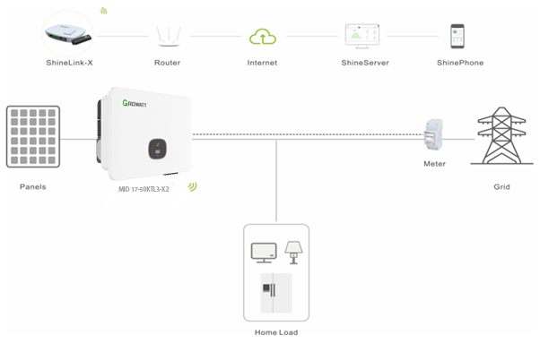

where the main components involved and their main functions are explained in the following table:

Name | Meaning | Function | Location
PMS | Power Management System | monitoring and management of power fluxes through the inverter, execution of local logic functions depending on grid parameters values | Inverter
Monitoring | WIFI/GPRS | Monitoring device to realize remote monitoring function | Monitoring device
Router | Router device | transmission of data to cloud server, reception of  commands/settings from external stakeholder | Third-party device
Meter | External Power Meter | meter at the AC input site, and possible  meter at AC port of third party generator/inverter, for power measures | Third-party device

and the subjects/parties involved in communications with the Growatt inverters are listed in the
following table, together with the purposes of the respective communications:

Subject | Meaning | Operations
End-user | mobile device (App), PC ( web portal) | monitoring of historical data, settings for special functions
Service | PC (via web portal) | remote diagnosis, system behaviour monitoring, remote updates, remote settings

2) All communications between internal components of the inverter, and supplied External Power Meter(s), take place via appropriate serial lines (RS485, CanBus) .
3) The only communication port between the inverter and the outside is constituted by the monitoring device on the system; the communication between inverter and the outside world can take place via an Ethernet line, WiFi or GPRS router according to the customer's request.
4) All communications between the Growatt server and the subjects/parties are cyber-protected by SSL
technology.
5) The cyber-security assessment of the Growatt was performed according to the ETSI EN 303 645
standard, and it is reported according to the Table B.1 form of the same standard:

EN 303 645 v2.1.1 (2020-06) Table B.1: Implementation of provisions for consumer IoT security
Clause number and title
Reference | Status | Support | Detail
5.1 No universal default passwords
Provision 5.1-1 | M C (1) | N/A | There is no default passwords for users
Provision 5.1-2 | M C (1) | N/A
Provision 5.1-3 | M | N/A
Provision 5.1-4 | M C (8) | N/A
Provision 5.1-5 | M C (5) | N/A
5.2 Implement a means to manage reports of vulnerabilities
Provision 5.2-1 | M | Y
Provision 5.2-2 | R | Y
Provision 5.2-3 | R | Y
5.3 Keep software updated
Provision 5.3-1 | R | Y
Provision 5.3-2 | MC (5) | Y
Provision 5.3-3 | MC (12) | N/A
Provision 5.3-4 | RC (12) | Y | The manufacturer manages the updates of the systems by means of remote automatic, selectively by type of machine or by activating  special functions at the request of the user
Provision 5.3-5 | RC (12) | N | Check note at 5.3-4
Provision 5.3-6 | RC (9,12) | N | Check note at 5.3-4
Provision 5.3-7 | M C (12) | Y
Provision 5.3-8 | M C (12) | N | note at 5.3-4
Provision 5.3-9 | R C (12) | N
Provision 5.3-10 | M (11,12) | Y
Provision 5.3-11 | RC (12) | N
Provision 5.3-12 | RC (12) | N
Provision 5.3-13 | M | Y
Provision 5.3-14 | R C (3,4) | N/A
Provision 5.3-15 | R C (3,4) | N/A
Provision 5.3-16 | M | Y
5.4 Securely store sensitive security parameters
Provision 5.4-1 | M | Y
Provision 5.4-2 | M(10) | Y
Provision 5.4-3 | M | N/A | hard-coded identity not used in source code
Provision 5.4-4 | M | Y
5.5 Communicate securely
Provision 5.5-1 | M | Y
Provision 5.5-2 | R | Y
Provision 5.5-3 | R | Y
Provision 5.5-4 | R | N
Provision 5.5-5 | M | Y
Provision 5.5-6 | R | Y
Provision 5.5-7 | M | Y
Provision 5.5-8 | M | Y
5.6 Minimize exposed attack surfaces
Provision 5.6-1 | M | Y
Provision 5.6-2 | M | Y
Provision 5.6-3 | R | Y
Provision 5.6-4 | MC(13) | N/A
Provision 5.6-5 | R | Y
Provision 5.6-6 | R | Y
Provision 5.6-7 | R | Y
Provision 5.6-8 | R | N
Provision 5.6-9 | R | Y
5.7 Ensure software integrity
Provision 5.7-1 | R | N
Provision 5.7-2 | R | N
5.8 Ensure that personal data is secure
Provision 5.8-1 | R | N/A
Provision 5.8-2 | M | Y | applicable to server/cloud services and to the customer App for mobile  devices
Provision 5.8-3 | M | Y
5.9 Make systems resilient to outages
Provision 5.9-1 | R | Y
Provision 5.9-2 | R | Y
Provision 5.9-3 | R | Y
5.10 Examine system telemetry data
Provision 5.10-1 | RC (6) | N
5.11 Make it easy for users to delete user data
Provision 5.11-1 | M | N/A
Provision 5.11-2 | R | N/A
Provision 5.11-3 | R | N/A
Provision 5.11-4 | R | N/A
5.12 Make installation and maintenance of devices easy
Provision 5.12-1 | R | N/A | no istallation/maintenance operations are available to the final user
Provision 5.12-2 | R | N/A | no istallation/maintenance operations are available to the final user
Provision 5.12-3 | R | N/A | check note at 5.3-4
5.13 Validate input data
Provision 5.13-1 | M | Y
6 Data protection provisions for consumer IoT
Provision 6.1 | M | Y | it only applies to the server/cloud side of the service
Provision 6.2 | MC (7) | Y | it only applies to the server/cloud side of the service
Provision 6.3 | M | Y | it only applies to the server/cloud side of the service
Provision 6.4 | RC (6) | Y
Provision 6.5 | MC(6) | Y
Conditions:
1) passwords are used;
2) pre-installed passwords are used;
3) software components are not updateable;
4) the device is constrained;
5) the device is not constrained;
6) telemetry data being collected;
7) personal data is processed on the basis of consumers' consent;
8) the device allowing user authentication;
9) the device supports automatic updates and/or update notifications;
10) a hard-coded unique per device identity is used for security purposes;
11) updates are delivered over a network interface;
12) an update mechanism is implemented;
13) a debug interface is physically accessible.

Status' Column:
M: Mandatory provision
R: Recommended provision
M C: Mandatory and conditional provision
R C: Recommended and conditional provision
Support' Column:
Y: Implemented
N: Not implemented
N/A: Not applicable

THD = Total Harmonic Distortion
PWHD = Partial Weighted Harmonic Distortion
THD = Total Harmonic Distortion
PWHD = Partial Weighted Harmonic Distortion
THD = Total Harmonic Distortion
PWHD = Partial Weighted Harmonic Distortion
THD = Total Harmonic Distortion
PWHD = Partial Weighted Harmonic Distortion

